Give top-layer of file folder structure to llm

https://g.co/gemini/share/24a4c260d2a7

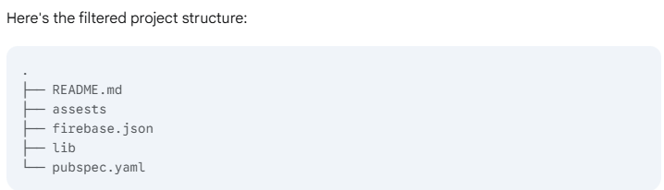

Give entire filtered file folder structure to llm for confirming

https://g.co/gemini/share/24a4c260d2a7

After confirming, give filtered complete file folder structure to llm to detect entry file

https://g.co/gemini/share/cf00f888a718

